23 March 2007 The Weekly Bulletin of Rotary Club of Kathmandu Mid-Town Bc # 38 of 2006-07
Rotary Club of Kathmandu Mid-Town
Breakfast Chatter




District : 3290 Web: www.rotarymidtown.org.np Club Id : 26776

MARCH IS WORLD ROTARACT (WEEK) MONTH
Today, there are more than 7,300 Rotary club-sponsored Rotaract clubs with some 170,000 members in over 150 countries. Rotaract Clubs are either based in the community or in a university. The clubs enable Rotaractors to grow personally and professionally, address community needs, and promote international understanding through friendship and service.

Guest Speakers Mr Joseph H Collins talked about positive factors in Nepal for having
international finance centre in Kathmandu at the Club meeting on 16 March 2007. Ms Brigitte Cazalis Collins talked about activities of Maiti Nepal in the United States
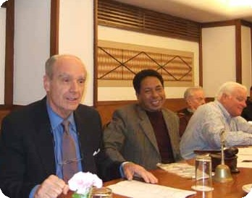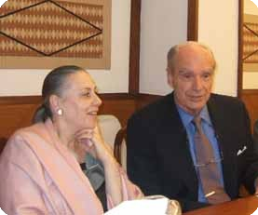
a) Guest Speaker Joseph Collins answering questions during interactions while
Acting President Subarna Joshi enjoys discussions; b) Ms Brigitte Collins listening carefully
to comments on her presentation.

Weekly Meetings and Programs :
Date | Program/Speaker | Program/Topics of Presentation
23 March 2007 | Rtr Prashanna Shrestha, | Joint meeting with Rotaract Club of KMT
30 March 2007 | Dinner meeting | Dinner meeting
6 April 2007 | Dr Lynn Bennett | ?
13 April 2007 | No meeting | Nepali New Year holiday

Friday, 23 March :
On Friday, 23 March 2007 the regular meeting will be the joint meeting with Rotaract Club of Kathmandu Mid-Town and Rotarct President Prashanna Shrestha will be giving a presentation on Rotaract activities.

Paris-Tokyo 260-day Run :
Frenchman Serge Girard did a 260-day run from Paris to Tokyo (19,097 kms), breaking the record for the longest journey without a full day of rest. He beat the world record held by the Australian Gary Parson who ran around his own country for 19,030 kms for 276 days without resting. He ran through 19 countries: from France to Japan via Germany, Austria, Italy, Greece, Turkey, Iran, Tajikistan, China etc.
Source: The Himalayan Times

$100 Laptop for Rural Schools ?
One Laptop Per Child (OLPC) Nepal has urged the government and other concerned sectors to extend necessary support to circulate the US$100 worth laptop computer free of cost in primary schools located in rural area of the country. OLPC Nepal, a non-profit organization, is currently localizing the contents and developing learning materials in Nepali and other indigenous languages for the laptop.
The president of OLPC Nepal said at a program that the concept of 100 dollar laptop was originally coined keeping in mind children of developing countries like Nepal, where quality education is not affordable and beyond the reach of the masses.
If we can distribute the laptops for free in schools located in rural areas, children will not only have access to similar learning materials that are being used by best schools of urban centers, but it will also bridge the digital divide prevalent in our country.
Since the laptop comprises electronic version of all text books, word processor, e-toys, drawing tools, camera, and inbuilt audio and video applications, no additional amount needs to be allocated for stationery and other learning and writing materials.
Designed in the US and manufactured by a Taiwanese company, the $100 laptop operates on Linux operating system and comes with a 366 Mhz processor, 128 MB RAM, 512 MB flash memory and a USB port and in-built multimedia tools such as stereo speakers and microphones.
It consumes 10 times less energy than normal computers and the battery can be charged manually, making the computer very suitable for Nepal.
Source: The Kathmandu Post

On Lighter Side : Click at the figure ⇩


Although some things in Rotary, like the Object of Rotary and the four Avenues of Service, do not change, our organization has evolved over the decades to find better and more efficient ways of meeting our goals. The Club Leadership Plan is one such tool. In it, we have an effective road map for organizing our clubs and allowing each one to work to its full potential, in every one of the four Avenues of Service.
RI President William B. Boyd

23 March 2007 The Weekly Bulletin of Rotary Club of Kathmandu Mid-Town Bc # 38 of 2006-07

Editor: RR Shrestha, Club Service Director email: rryes@wlink.com.np

